The Five Most Used Apps Android Phone

Make and Receive Phone Calls
- App: Phone
- How:
  - Tap the green phone icon.
  - Dial a number or tap a contact.
  - To answer a call, swipe the green button when it rings.

Send and Receive Text Messages
- App: Messages
- How:
  - Tap the blue speech bubble icon.
  - Tap “Start chat” or “+”.
  - Type a message and tap the send arrow ➤.

Use Google Maps for Directions
- App: Google Maps
- How:
  - Tap the colorful map icon.
  - Type a location (e.g., “pharmacy”).
  - Tap “Directions” and follow the blue route.

Stay Organized with Calendar & Reminders
- Apps: Google Calendar & Clock
- How:
  - Tap the calendar icon to add events.
  - Use the clock app to set alarms or timers.
  - Add reminders for appointments or tasks.

Take and View Photos
- Apps: Camera & Gallery
- How:
  - Tap the camera icon and press the shutter button.
  - Open Gallery to view and share.
  - Tap a photo to edit, delete, or send.

Bonus: Learn Basic Settings
- App: Settings
- How:
  - Swipe down from the top of the screen.
  - Tap the gear icon to open full settings.
  - Adjust Wi-Fi, brightness, volume, and more.

Home Button

At the bottom of Apps when an App is in use the following 3 icons appear:
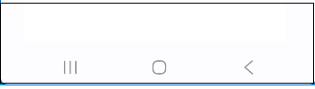
Tap to show all open Apps
Tap the Home button
Tap to go back one screen

When all the app windows are showing you can swipe left or right and tap to engage that app. The app you have left remains in play.

Tap the home button to end the app and show the main screen of icons.

In apps like Contacts there are functions like EDIT. When you are in one of those sub windows you can use the back icon to exit out of that.

App:  Phone
Speed dial numbers Open to keypad Settings
Search Contacts

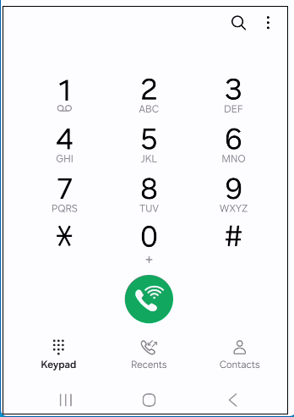
Tap to toggle between
Keypad (this image) –
Recent calls made or received –
Contacts App
Tap to dial
Press and hold for + sign for INTL call
Press and hold to dial into voice mail

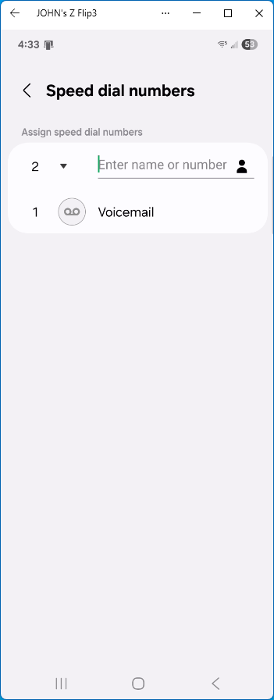

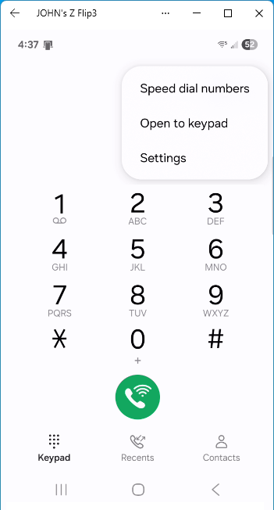
Tap to toggle between
”open to keypad”
And
“open to last viewed”

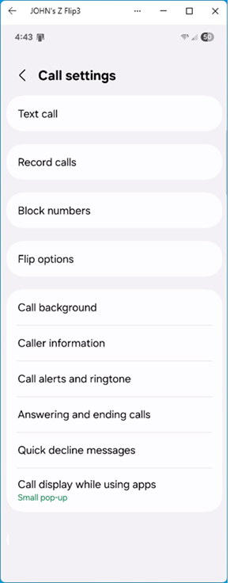

(swipe down to see these options)

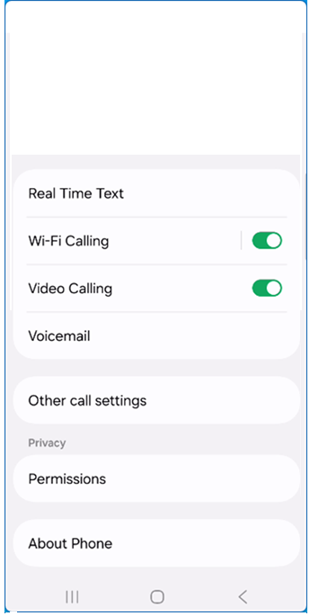

App:  Messages
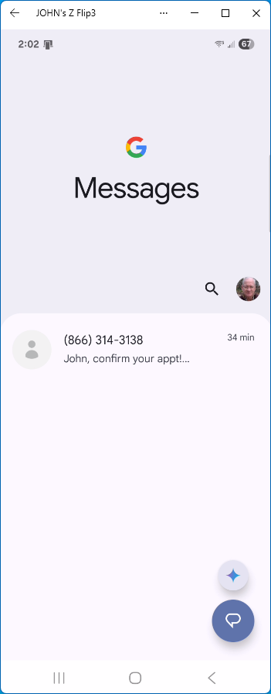
Gemini

Start a new message

messages

Account profile
Options
Settings

Search messages

Tap the start a new message icon 
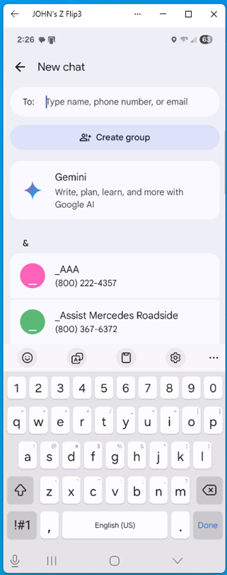
Tab each character to define the TO:

Create a group of people to send text to

Identify who you are sending TEXT to

Contact database
TAP the one to send to

Tap on an incoming message
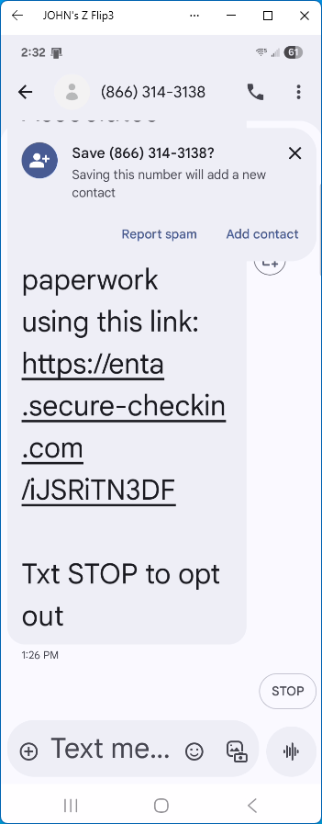
If this is not a contact already in your CONTACTS
Tap Add contact
You can assign a name, address and other info in the Contacts app

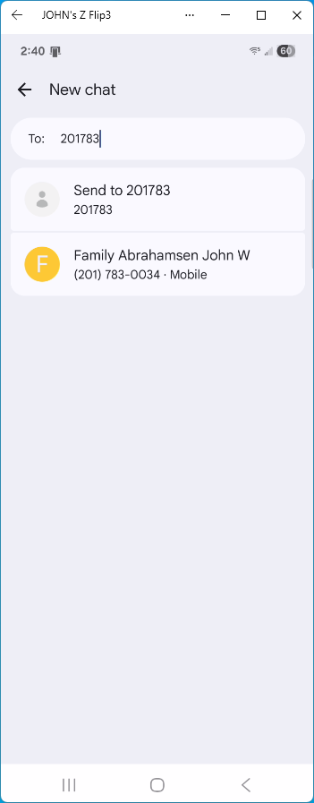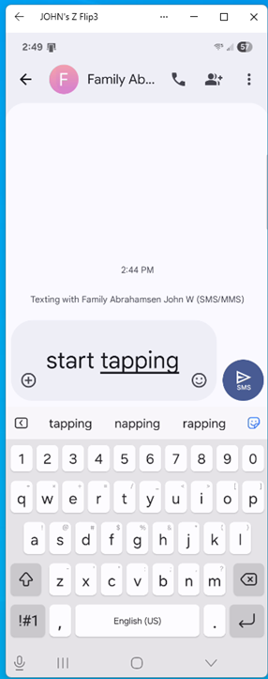
As you enter this number
All possible matches in your Contacts will be displayed
You can tap that entry “Like Abrahamsen John” to complete the TO:

Tap the icon to send the message

Enter your message by tapping on the keyboard
A spelling tool banner tracks you
Tap the word if you wish to use that suggestion

App:  Google Maps
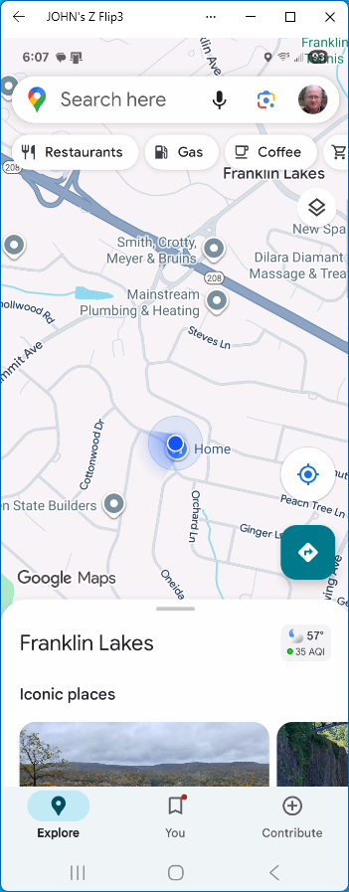
Swipe down to close this
More map can be viewed
Use pinching fingers to make map larger or smaller
Touch and drag to move map around

The blue dot is where you are
When the phone moves the dot will move

Tap the Search here
A keyboard will appear in which you can enter an address
Also a list of recent addresses might appear

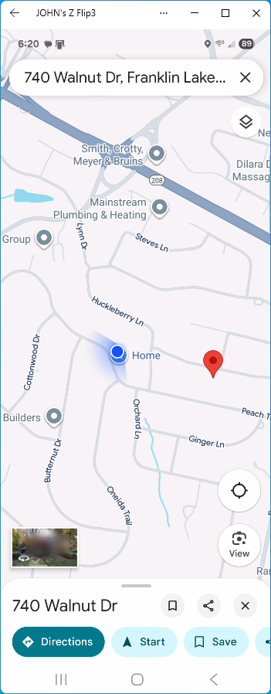
Tap to get more info and options
Or
Tap Start

The red dot shows the location of the entered address
As the phone moves the blue and red dots will get closer or further away

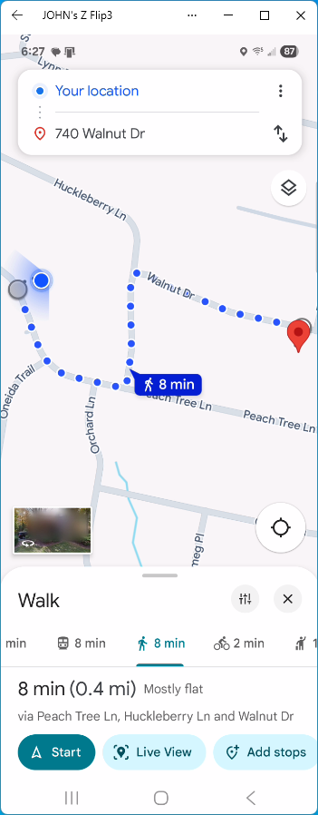
Tap Start and the App will track your progress and provide directions real time

Tap one of these methods to see that travel plan and stats

The suggested route is displayed by Google including the method of travel

Tap the arrows to reverse the origin and destination

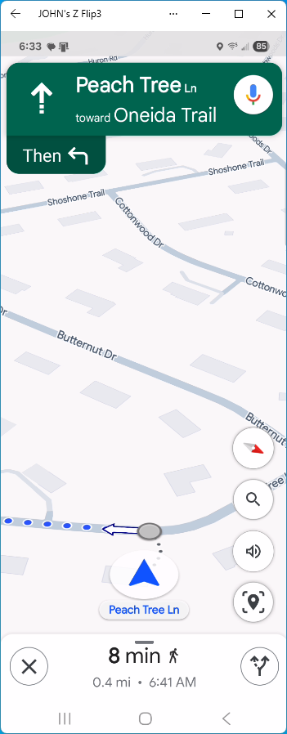
TAP TO HAVE GOOGLE SPEAK THE DIRECTIONS
Provides hands free driving option

directions

Apps: 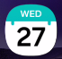 Google Calendar & 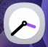 Clock

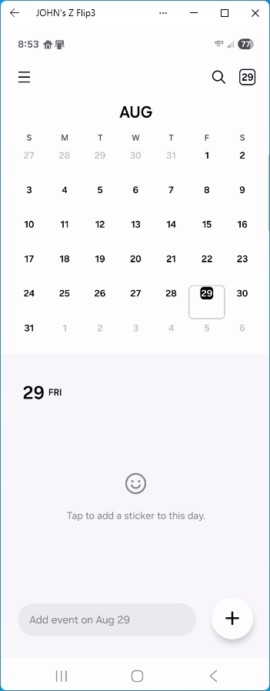

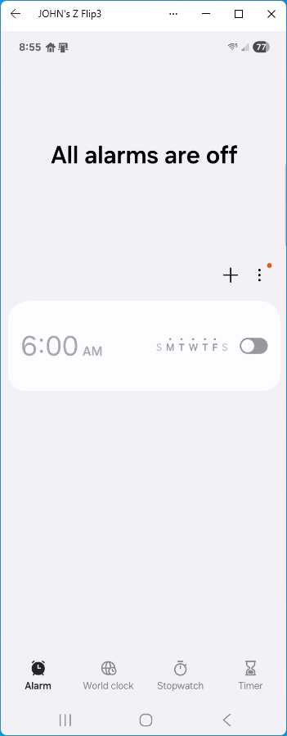

Apps:  Camera &  Gallery

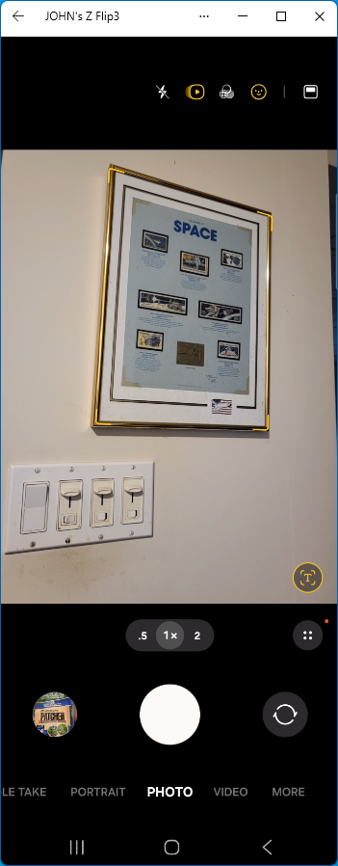
Tap for Photo or Video
Or other actions

Tap to take picture

Tap to toggle front and back cameras

Flash on and off
Special effects

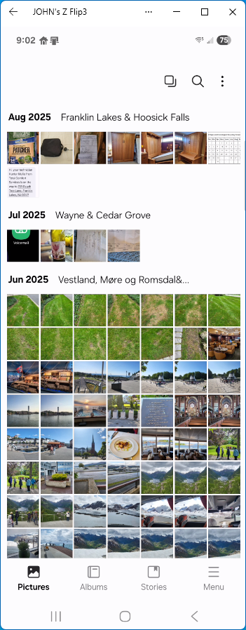
Tap to open menu

search
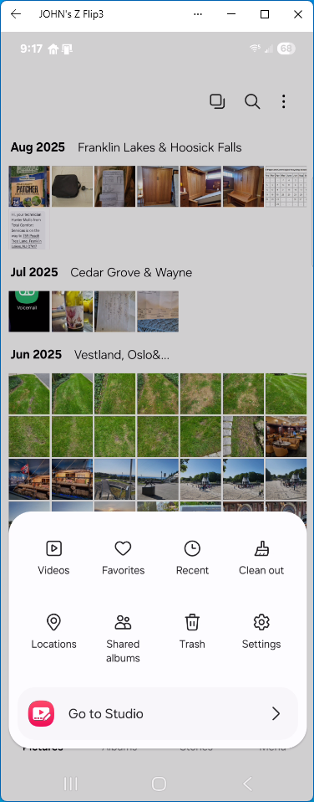
Tap to go to settings

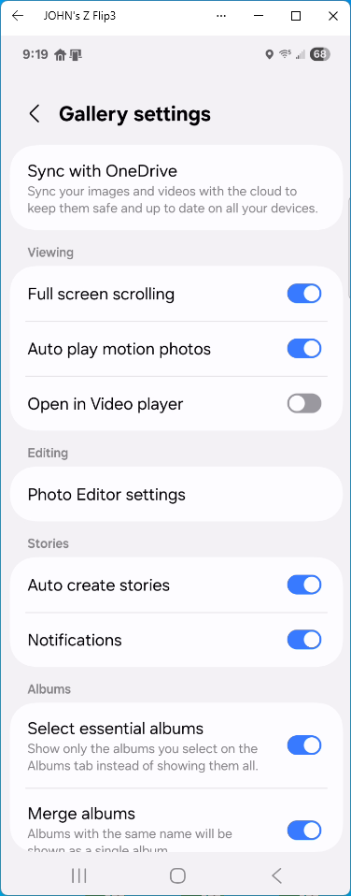

SWIPE DOWN to see all setting options
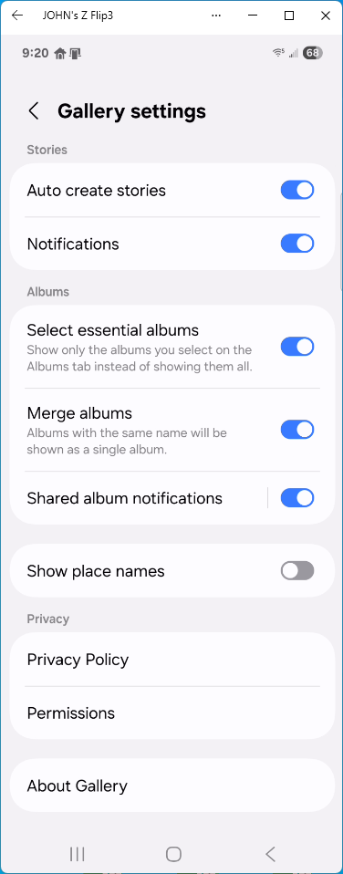

App:  Phone Settings

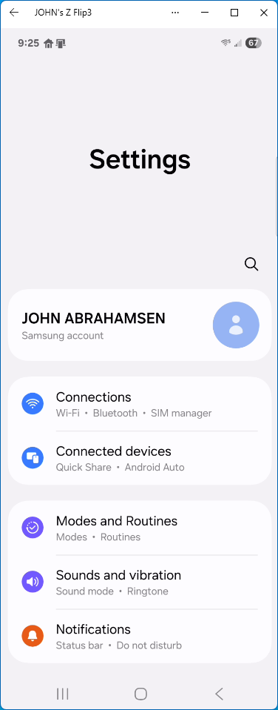
Tap the settings ICON

To see all the setting options SWIPE DOWN – TAP the setting option to view or change
